EXERCISE-17

17.Design TM using simulator to accept the input string Palindrome ababa

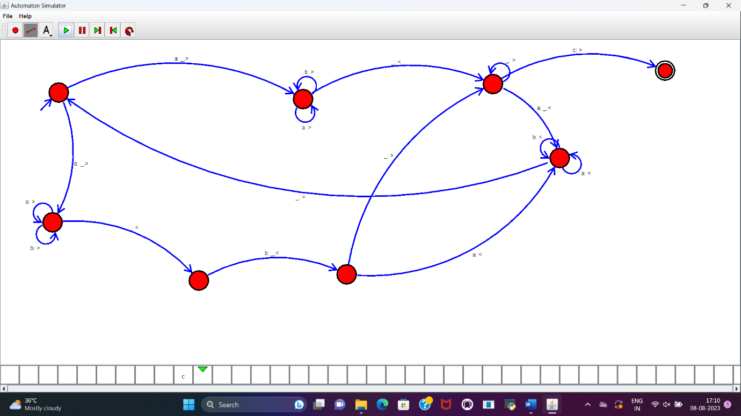

RESULT:

TM to accept the string palindrome ababa is designed and implemented successfully.